Conviction Database – Purchasing Credits

Quick Reference (At-a-Glance Guide):
- Log into your Criminal History Conviction Name Search account.
- Scroll down under Returning Users, click Conviction Database Download.
- Review the Instructions and click continue
- Review the Public Criminal History Database Agreement, check the Required box and click continue.
- Complete the Credit Order Form with the number of download credits needed.
- Click “Print the form” and include with your check/money order.
- Mail to:
Texas Department of Public Safety
Crime Records Division
P.O. Box 15999
Austin, TX 78761-5999

Detailed Instructions: Log into your Criminal History Conviction Name Search account.
- Go to the Criminal History Conviction Name Search home screen.
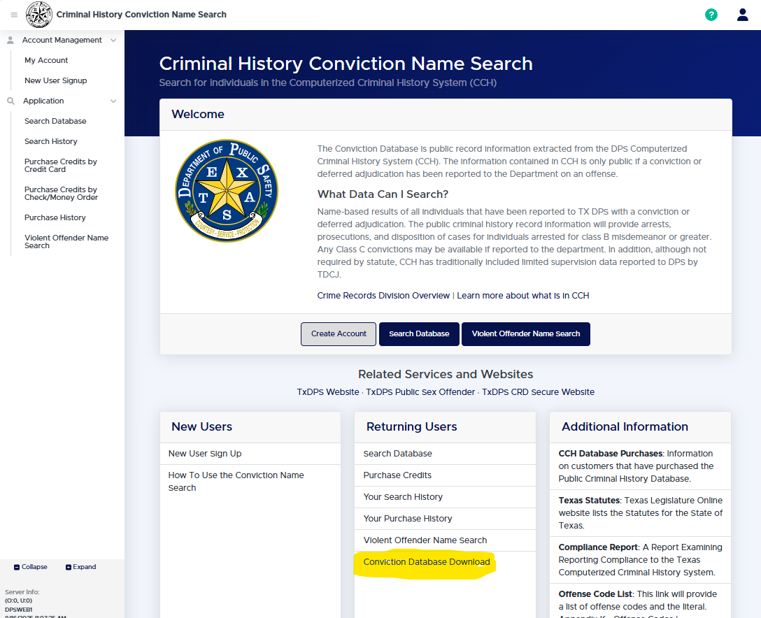
- Access the Order Form
  - Select the Conviction Database Download tab under Returning Users.
  - Review the Instructions and confirm the Agreement page.
  - You will then be directed to the Order Form.
- Complete the Order Form
  - Enter the number of credits you wish to purchase.
  - The Total Cost will be automatically calculated and displayed along with your account information.
- Submit Payment
  - Print the completed order form.
  - Attach your check or money order and mail it to the address above.

